HELLO

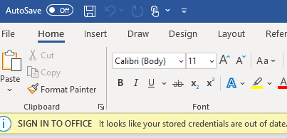

**This is the normal bolded text.**

Link to [google](http://www.google.com).